11 HUMAN BIOLOGY
MICROSCOPE PRACTICAL TEST

NAME: -_______________________________________________________________
Question 1
Show your working in all of the following problems.
A microscope has the following lenses:
ocular power = 10x
low power objective = 20x
high power objective = 50x
- What is the highest magnification you could get using this microscope? ________________________________________________________________________________________________________________________________
- If the diameter of the low power field is 2 mm, what is the diameter of the high power field of view in millimeters (mm)?
______________________________________________________________________________________________________________________________________
in micrometers (μm)?
______________________________________________________________________________________________________________________________________
- If 10 cells can fit end to end in the low power field of view, how many of those cells would you see under high power?
______________________________________________________________________________________________________________________________________
Question 2
Show your working in all of the following problems.
Another microscope has the following lenses:
ocular power = 10x
low power objective = 10x
high power objective = 40x
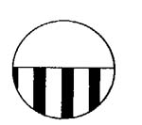
The diagram shows the edge of a millimeter ruler viewed under the microscope with the lenses listed above. The field shown is the low power field of view.
- What is the approximate width of the field of view in micrometers (μm)?
____________________________________________________
b) What would be the width of the field of view under high power?
______________________________________________________________________________________________________________________________________
c) If 5 cells fit across the high power field of view, what is the approximate size of each cell?
______________________________________________________________________________________________________________________________________
Question 3
ocular = 10x
low power objective = 20x
high power objective = 40x
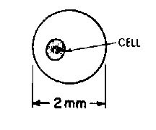
The picture shows the low power field of view for the microscope with the lenses listed above.
a) What is the approximate size of the cell in micrometers (μm)? __________________________________________________________________________________________
b) What would be the high power field of view?
______________________________________________________________________________________________________________________________________
c) How many cells like the one in the picture could fit in the high power field of view?
______________________________________________________________________________________________________________________________________
Question 4
The microscope image below is of some human epithelial tissue taken from the lining of the mouth. In the space to the right do a biological drawing of one of the cells and label the parts.

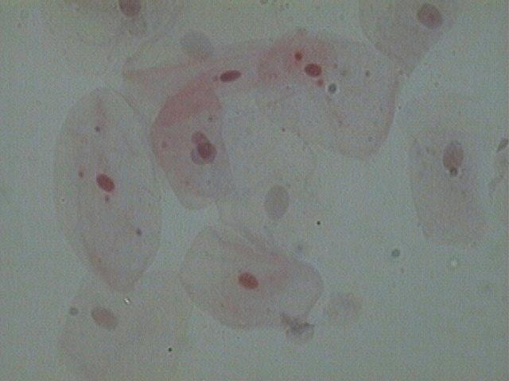

If the scale bar is 2600 μm long. How long is the typical epithelial cell that is on the far left of the image? Show working.
_________________________________________________________________________________________________________________________________________________________________________________________________________
Question 5
Draw and label two of the striated muscle fibres seen in the microscope image below

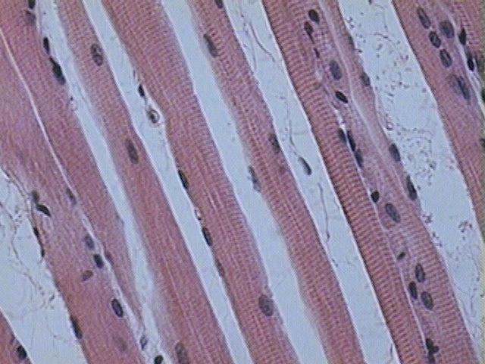

Where in the body do you find striated muscle tissue?

______________________________________________________________________________________________________________________________________________________
___________________________________________________________________________

ANSWERS to Question1:
ocular power = 10x
low power objective = 20x
high power objective = 50x
- What is the highest magnification you could get using this microscope ?
500x
Ocular x high power = 10 x 50 = 500. (We can only use 2 lenses at a time, not all three.)
b) If the diameter of the low power field is 2 mm, what is the diameter of the high power field of view in mm ?
8 mm
The ratio of low to high power is 20/50. So at high power you will see 2/5 of the low power field of view (2 mm). 2/5 x 2 = 4/5 = .8 mm
in micrometers ? 800 micrometers
To convert mm to micrometers, move the decimal 3 places to the right (multiply by 1000). .8 mm x 1000 = 800 micrometers
d) If 10 cells can fit end to end in the low power field of view, how many of those cells would you see under high power ? 4 cells.
We can answer this question the same way we go about "b" above. At high power we would see 2/5 of the low field. 2/5 x 10 cells = 4 cells would be seen under high power.
ANSWER to Question 2:
ocular power = 10x
low power objective = 10x
high power objective = 40x
The diagram shows the edge of a millimeter ruler viewed under the microscope with the lenses listed above. The field shown is the low power field of view.
a) What is the approximate width of the field of view in micrometers ? 3500 - 3800 micrometers
Each white space is 1 mm. We can see approximately 3 1/2 (or so) white spaces. That is equivalent to 3.5 mm, which converts to 3500 micrometers. Any answer in the range above would be OK.
b) What would be the width of the field of view under high power ?
875 micrometers
The ratio of low to high power for this microscope is 10/40 or 1/4. So, under high power we will see 1/4 of the low power field of view. 1/4 x 3500 micrometers (from "a" above) = 875 micrometers.
c) If 5 cells fit across the high power field of view, what is the approximate size of each cell ?
175 micrometers
If 5 cells fit in the high power field of view (which we determined is 875 micrometers in "b"), then the size of 1 cell = 875/5 = 175 micrometers.
ANSWERs to Example #3:
ocular = 10x
low power objective = 20x
high power objective = 40x
The picture shows the low power field of view for the microscope with the lenses listed above.
a) What is the approximate size of the cell in micrometers ?
500 micrometers
First, we have to visualize how many of those cells could fit across the field --- about 4. So 2 mm (the width of the field) / 4 = .5 mm, which converts to 500 micrometers.
b) What would be the high power field of view ?
1000 micrometers
The ratio of low to high power for this scope is 20/40, or 1/2. So we will see 1/2 of the low power field under high power. 1/2 x 2 mm = 1mm, which converts to 1000 micrometers.
c) How many cells like the one in the picture could fit in the high power field of view ?
2 cells
Again the ratio of low to high power is 20/40, or 1/2. If we can see 4 cells across the low field of view we will see 1/2 as many in the high field of view. 1/2 x 4 = 2 cells.

